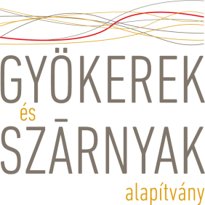
CODE OF CONDUCT
The Foundation recognizes every person’s right to live in equal dignity as individuals, with special regard to children and vulnerable adults; therefore the protection of vulnerable social groups is one of the main priorities in the general mission of the Foundation and it should be a key principle for its partners as well.
The staff member of the Foundation implements the Safeguarding Policy in his/her work and ensures that all staff members are fully aware of it. These values laid down also serve as objectives and guidelines which he/she strives to realize/follow during his/her work.
Keywords in the documents which lay down the values connected to his/her work include: cooperation, openness, inclusion, high-quality and precise professional work, understanding and attention, teamwork, mutual trust, sincerity, honesty, action, creative desire, a positive and constructive attitude, self-improvement, and respect for knowledge.
The Roots and Wings Foundation and all partners of the Foundation agree completely with the ‘Do no harm’ principle. The Foundation strongly condemns all kinds of harms and violence targeted to children and vulnerable adults.

Reporting Procedure
If employee, volunteer or any other staff member of the Foundation will recognize any case of harm or abuse, she/he must report such concerns to the responsible person of the Foundation. In this case he/she should immediately use the Incident Report Form of the Foundation which helps to make a written report about the specific incident. Based on the special case of the current incident, the Foundation should take an immediate action to protect the child or vulnerable adult. All necessary legal steps should be taken according to the local situation.
I am in agreement with the following norms as a formal/informal member of the staff:
- I understand the values of the Safeguarding Policy.
- In the daily work there is a high priority of the protection of children and vulnerable adults.
- All activities, including activities of supported organisations, of the Foundation must be designed to protect children and vulnerable adults in their locality – as a safe project.
- I will reduce the risk of harm as much as possible.
- Under the umbrella of the organization, Foundation’s I always create safe environment and activities for children and vulnerable adults.
- I will ensure good practices when we create media contents for the Foundation, including following our social media standards!

I declare that I have carefully read the Code of Conduct and I will implement the values in my work.
Signed by……………………………………………………….......…………/Date………………………………

