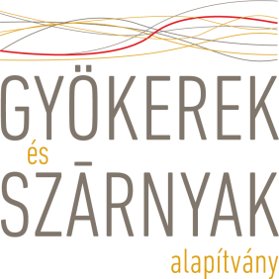
Definition of harm and abuse of children/vulnerable adults

The meaning of harm: When adults or other children hurt children or vulnerable adults, in any way. There are different kinds of harm and abuse.
’Physical Abuse: The use of physical force that causes actual or likely physical injury or suffering (e.g., hitting, shaking, burning, female genital mutilation, torture).
Emotional abuse: Any humiliating or degrading treatment such as bad name calling, constant criticism, belittling, persistent shaming, solitary confinement and isolation.
Neglect/Negligent Treatment: Persistent failure to meet a child’s basic physical and/or psychological needs, for example by failing to provide adequate food, clothing and/or shelter; failing to prevent harm; failing to ensure adequate supervision; or failing to ensure access to appropriate medical care or treatment.
Sexual Abuse: All forms of sexual violence, including incest, early and forced marriage, rape, involvement in pornography, and sexual slavery. Child sexual abuse also may include indecent touching or exposure, using sexually explicit language towards a child and showing children pornographic material.
Sexual Exploitation: Any actual or attempted abuse of a position of vulnerability, differential power, or trust, for sexual purposes, including, but not limited to, profiting monetarily, socially or politically from the sexual exploitation of another. This includes exchange of assistance due to children benefiting from Save the Children programming. The sexual exploitation of a child who is under the age of consent is child sexual abuse and a criminal offense.’

Safe the Children – http://www.savethechildren.org/atf/cf/%7B9def2ebe-10ae-432c-9bd0df91d2eba74a%7D/SCUS%20CHILD%20SAFEGUARDING%20POLICY%20(WATTACHMENTS)%20(11%2005%2015)%20DOC.PDF

